Natural Computing Algorithms

Banuka Vidusanka, Paniyan Duwage - 14040305

1 INTRODUCTION
Task given is consisted with 3 separate data records with different characteristics. “Data1” & “data2” were binary data while “data3” contained real-valued data. Objective was to evolve a system that correctly classify given set of input variables, in a way giving the predicted variable as the output. Main part of the problem was to sort the data in a way to process and to choose what data to be used as a training set. Data set 3 also required fine tuning in order to be used as a training set.

2 BACKGROUND RESEARCH
Evolutionary computation is a sub-field of artificial intelligence and closely associated with computational intelligence. It is engaged in problem solving systems that use computational models with evolutionary processes derived from biological concepts such as genetic inheritance and natural selection. Techniques in this field are used on problems that have too many variables for traditional algorithms to consider and in times where the approach to solving a given problem is not well understood.

Data mining in general refers to the process of analysing data from different perspectives and summarizing it into useful information. The kind of information that is useful in increasing revenue, cut costs or other research areas. (Raorane and Kulkarni 45-56) Data mining software is a tool that allow uses to analyse data from different perspectives, categorize it, and summarize the relationships determined.

“The internet, or world wide web as we know it was born in 1991. HTTP became the standard means for sharing information then. According the studies by IDC and EMC, the amount of data created in 2003 surpasses the amount of data created in all human history before then. It is estimated that 1.8 zettabytes (ZB) was created in 2011 alone.” (Dean, 2013)

In 2008 the number of devices connected to the internet exceeded the world’s population. The events of last 20 years have fundamentally changed the way data is treated. It is created by us every day. It is not a waste product but buried till put to good use.

Walmart; American partner of ASDA is one of the biggest retailers in the world processing over 20 million point of sale transactions every day. This information is stored and processed through data mining software to determine sales, develop marketing strategies and predict customer loyalty. This information is also used to decide floor planning of the shop floor as in where to place each items in each season and festive periods in hope to drive sales and allow easy access for customers.

Market basket analysis is the data-mining in retail sector. Through this retailer can follow alpha consumers’ purchase patterns and predict future buying trends to forecast supply demands.

Multifactor dimensionality reduction or MDR is a data mining strategy for detecting and characterizing nonlinear interactions among discrete attributes such as SNPs, smoking, gender: that are predictive of a discrete outcome. (Moore et al. 252-261) It intends to detect how the changes in one’s DNA sequence affects the risks of developing common diseases such as cancer, which is of great importance to improving manner of diagnosing, averting, and treating these diseases.

Data is the new oil. It has all the same challenges in that it is plentiful but difficult and sometimes very messy to extract. There are few that control most of it, and others transport, refine and distribute it. The goal is to use it wisely.

3 EXPERIMENTATION

3.1 Data Set 1

My strategy to solve the problem as follows.
- Create an initial Population
- Repeat until a good solution has been found or time exceeded
  - Evaluate the fitness of each individual/chromosome
  - Select chromosome for reproduction
  - Create new chromosomes with the use of crossover & mutation
  - Replace chromosomes in population

My genetic algorithm reads in each line from the text file provided and save it in to an array-list. Then the program generates a random integer of a specified length. Then the integer is broken in to rules and passed through several strategies such as mutation, crossover and selection. Then the fitness function is calculated by comparing the generated numbers against the data from input text file.
I have collected data by changing the input variables: population size and gene length.

LEGEND for Data set1: Series 1 = Genes 10, Series 2 = Genes 50, Series 3 = Genes 100,

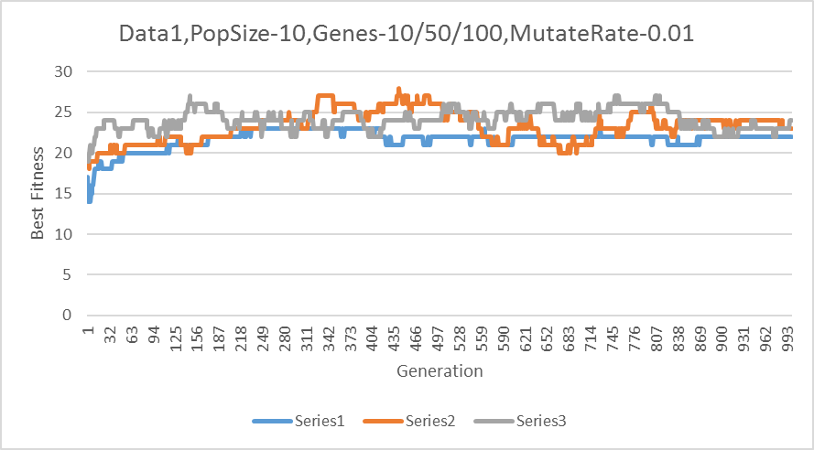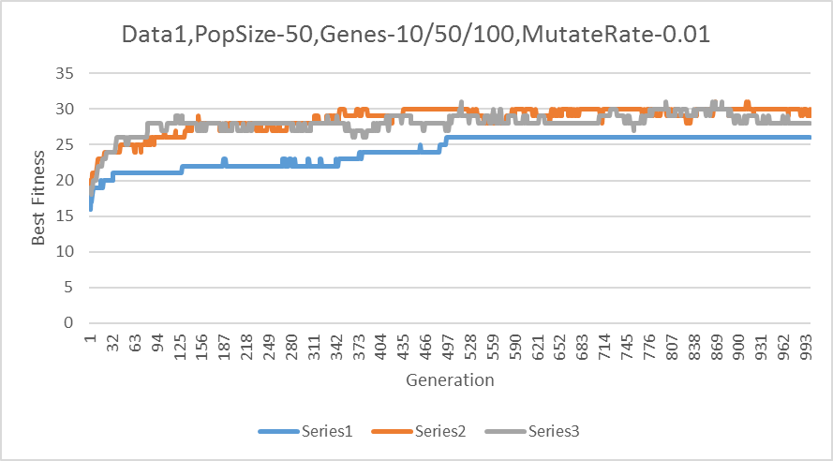

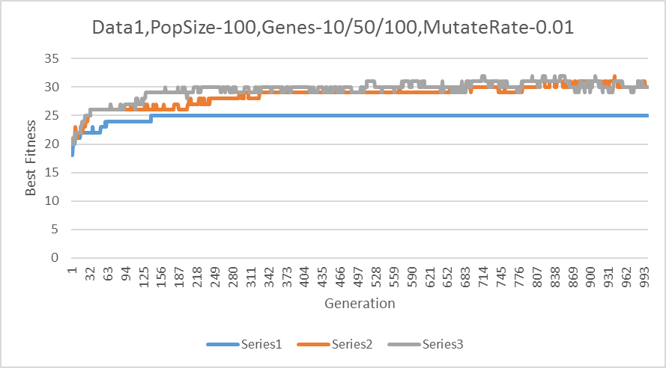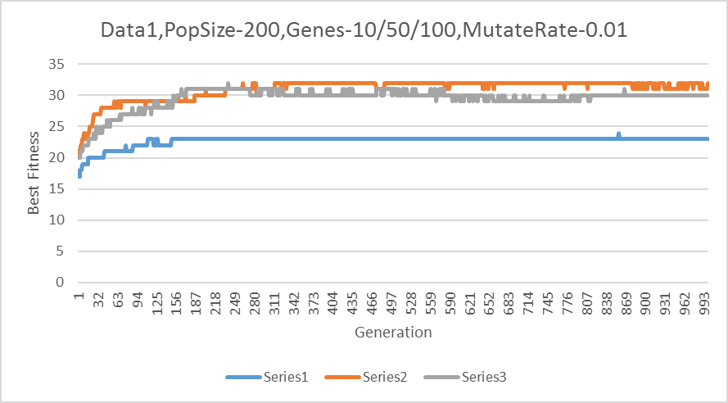

According to the graphs when the initian population size is lower, it takes longer(more generatiosn to reach Best Fitness and even then it can keep moving back and forth. When set to higher population size, better Fitness value is discovered. Higher the Gene length in initialization, better fitness value produced.

3.2 Data Set 2

Data1 and Data2 files used similar GA.

3.3 Data Set 3 (and UCI data)

4 CONCLUSIONS
In order to get higher fitness in reasonable amount of time, it is important to have large amount of initial population. That way it provides variety in the gene pool in consideration. Mutation is best to kept at lowest (0.01). Without mutation program will continuously change without reaching optimum value.

REFERENCES

(Raorane and Kulkarni 45-56)
Raorane, Abhijit and R V Kulkarni. "Data Mining Techniques: A Source For Consumer Behavior Analysis". International Journal of Database Management Systems 3.3 (2011): 45-56. Web.

(Dean, 2013)
Dean, Jared. High Performance Data Mining And Big Data Analytics. 1st ed. Hoboken, NJ: Wiley, 2013. Print.

(Moore et al. 252-261)
Moore, Jason H. et al. "A Flexible Computational Framework For Detecting, Characterizing, And Interpreting Statistical Patterns Of Epistasis In Genetic Studies Of Human Disease Susceptibility". Journal of Theoretical Biology 241.2 (2006): 252-261. Web.

Code can be found on:
https://github.com/banukaknight/BioComputation

